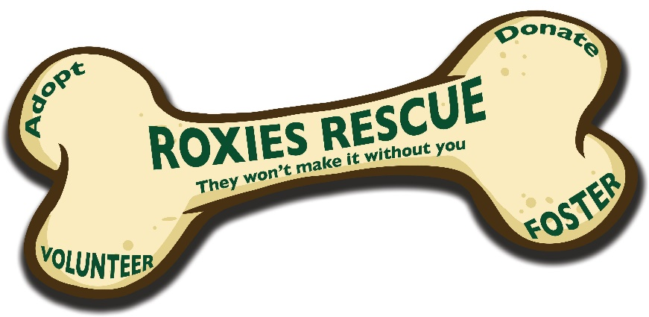

Animal surrender request form

Name of the animal you wish to surrender: Age:
Species: Breed: Sex:
Colour/markings:
Has the animal been neutered? Y/N Vaccinated, with certificate: Y/N Microchipped: Y/N
How long have you owned the animal?
Brief description of the animal’s personality/ behaviour, include any behavioural concerns that we should be made aware of:

Owner's reason for parting with animal:

What vet is your pet currently registered with?
When was there last check up at the vets?
Does the animal have any known allergies?
Has your animal had any previous operations or treatment for medical conditions?

Does your animal have any medical conditions that are undergoing treatment? Please be honest, this helps us ensure they receive the correct care!

Has the animal ever lived with children? Yes/no
If yes, please specify the ages of children and animal's behaviour:

Is the animal comfortable with both men and women?
Has the animal ever shown aggression, bitten or scratched any human or animal? If yes, please give details…

Does the animal display any abnormal behaviours in any of the following situations?
Grooming: Y/N Veterinary visits: Y/N Travelling: Y/N
Walking: Y/N Being left alone: Y/N Loud noises: Y/N
If you answered yes to the previous question, please give details:

Has the animal ever been destructive in the house? Please describe

Has the animal lived with dogs? If so, please specify age, sex and reaction

Has the animal lived with Cats? If so, please specify age, sex and reaction

Please describe your animal's feeding regime: please include current brand of food, do you allow scraps, dry or tinned, preferred flavours, feeding times, quantities, likes/dislikes and any dietary issues:

Is the animal toilet trained/ litter trained? Y/N
Is your dog crate trained? Y/N
How often is your dog walked?

Please provide your full contact details:

In completing this form, you (the current owner) understand that Roxies rescue will use your pet’s information to create a foster advert that will be shared on social media and to our website. Contact details will only be shared within our small admin team and will not be shared externally without prior authorisation.
Please give the rescue time to find a suitable foster family for your pet, its important that we carefully select the best family to reduce the chances of a foster placement breaking down. If you find a home elsewhere, please inform us asap.
In the event that we are unable to offer support with rehoming, we will inform you.

Signature of owner:
Date:

Please attach some photos and return your form to roxiesrescue1@gmail.com

